**29-11-2021 ML SPOT – 13 2019103573**

**IMPLEMENT ANY TWO ENSEMBLE CLASSIFIERS**

**ADABOOST**

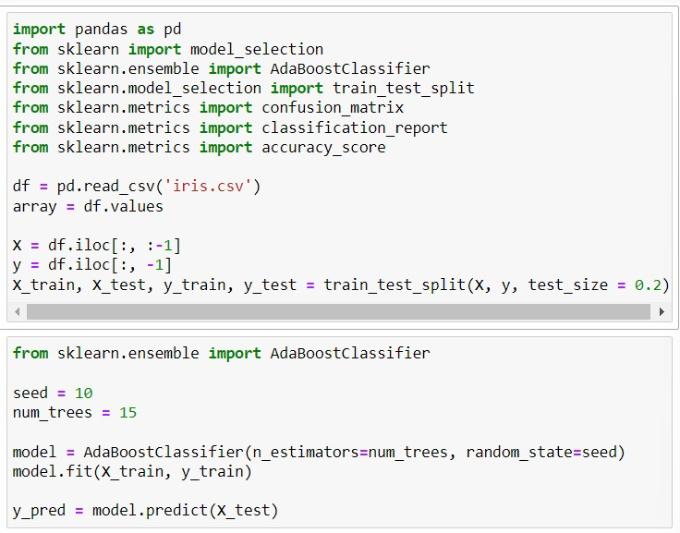

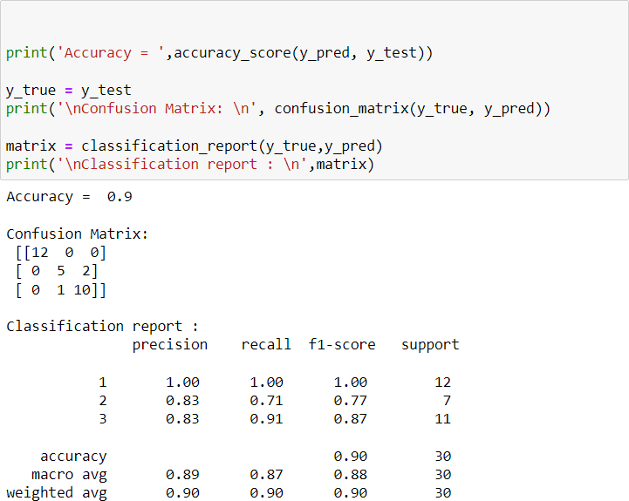

BAGGING CLASSIFIER

